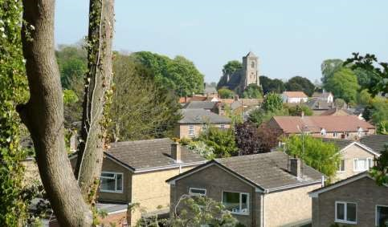

The Newsletter for Middleton on the Wolds

Issue No 16

June 2020

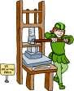
NEXT COPY DATE
14th June

Please send in your contributions to middletonflyer@yahoo.com. If I don’t acknowledge them please get in touch to make sure they have arrived.

After the news last month from Rupert that the Black Yak employees in Nepal had returned to their own villages because of the coronavirus lockdown , it is good to read that they are now back at work with safety measures in place (advertising feature on the inside cover).

This month we have again had a limited number of copies printed which will be available in the Post Office. Please do not take one of these if you are able to read it online, but do take one for a neighbour without a computer. We hope that it won’t be too long before it is considered safe for the teenagers to, once again, deliver to your doors.

Lyn

4 The Paddocks 219500

PRODUCE SHOW 2020
Just a reminder that the Produce Show has been cancelled this year. Entries for the Handicraft and Photograph Sections may be used at next year’s show.
Sue Howden
Show Secretary

editorial
Day six hundred and ninety-three (or something). Garden sorted (although this may be revised in light of garden centres now being open), gutters cleaned, patio powerwashed and nearly all books in the house read. Trees waxed and polished and anything not moving in the garden has been burned, buried or composted. You never know, I might soon be running out of things to fill my time! On the
other hand, the chip van is back (repairs permitting), Mike and Lynn are doing takeaways from the Robin Hood and just this morning I managed to buy some flour from Morrison’s.
Does this mean we’re over the hump? Well, lockdown measures have been relaxed slightly, if confusingly, but only in England. We’ve been allowed more freedom of movement. We can now visit family members and more shops are opening. Just remember to comply with social distancing. And when you have to go out wear a face mask, especially if you’re using public transport. I have to admit I wasn’t too sure about the face mask thing; what swayed me was the principle that wearing one made it less likely that I would pass the virus on if I had it. So I’ve started, even if its just pulling a scarf over my nose and mouth – not perfect but better than nothing at all.
I’ve been saddened by two instances of fly tipping on Beverley road. I’d like to say it beggars belief but as we all know, some people are just far too important to think about the rest of us (and I include not cleaning up after your dog in this). ‘I’m alright, Jack’ would be a fitting motto for them. If you know who did it then please report them. If you did it, why are you living in Middleton?
On a happier note most people seemed to have a good time commemorating
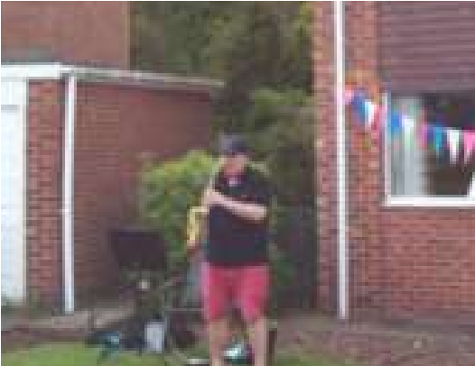
VE day (although the fact that it was a Bank Holiday came as a complete surprise to me!).There was plenty of bunting and a fine selection of flags and posters adding to the red, white and blue-ness of the village. We had a walk round in the afternoon, sadly too late to crash (in a social distancing kinda way) any of the many garden parties, especially on Greenfield Road. And I must mention the keyboard and saxophone rendition of We’ll
Meet Again. Above and beyond, gentlemen; above and beyond.
You see? Lockdown isn’t all bad and it does seem to be working. By minimising contact with others we have helped slow down the rate of infection and given the emergency services a bit of breathing space. So, just because you can go out now YOU DON’T HAVE TO. Remember, easing lockdown doesn’t mean we have Coronavirus under control, it just means you’ll have more of a chance of getting an ICU bed if you get it!
Cheers, Mike
If you have any ideas, comments or complaints (especially complaints) you want to share then send an email to middletonflyer@yahoo.com.
Remember, we can’t respond unless we receive your message.
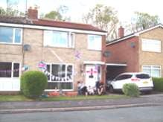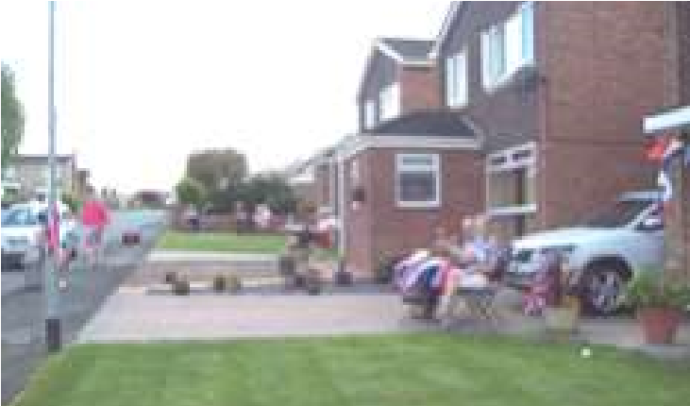

VE Day Pictures by Denise Wales
ADVERTISING COSTS for the Messenger

Rates Month Year

Whole Page £25 £150

1/2 Page £15 £100
1/3 Page £10 £60

Full colour - Print run 500 copies

Contact: Tina 01377 217242, middletonflyer@yahoo.com

QUIZ PAGE
- Which is England’s largest national park?
- Which famous ship is berthed at Greenwich?
- Who is the youngest person to be credited with a UK number one hit?
- Which is the only British city whose name begins with "I"?
- How many Olympic Gold Medals were won by team GB in London 2012?
- How much dirt is there in a hole that measures two feet by three feet by four feet?
- What is the state capital of California?
- When was the euro introduced as legal currency on the world market?
- On the London Underground tube map, what colour is the Bakerloo line?
- Which author wrote 20,000 Leagues Under The Sea?
Quiz set by Rowland Wooldridge
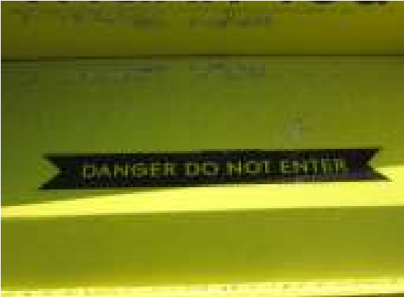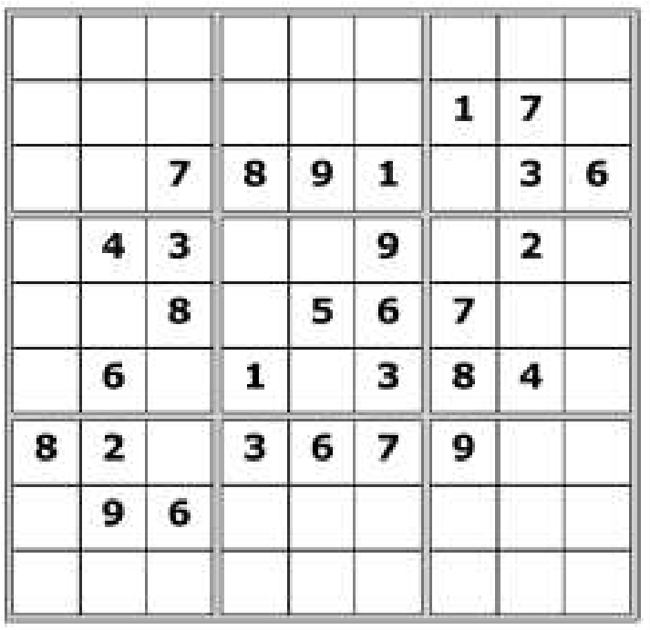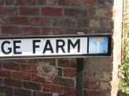

MOVIE DINGBATS

SUDOKU

WHERE IN MIDDLETON?

All answers on page 21

Photos by Ian Lavender

Belated obituary

Alan Escritt Walker

Alan passed away suddenly at home on 28th February. He was 75 years old.
A funeral service, which was well attended, was held at the East Riding Crematorium on 20th March led by Rev Robert Amos. The organist was Mr Steven Westaway. Also well over 60 people declined to attend because of the virus.
Alan was born on 2nd April 1944 to parents Frank and Julia Walker at home in Middleton on the Wolds, where he lived his entire life. He was brought up with his elder sisters, Joyce and Joan. His older brother, Derek, died a few months before Alan was born, aged 9 years.
He went to school in Front Street and later to Driffield. He was happy to recall that he cycled to Driffield, played football for the school team, then cycled home again each Saturday during the season. He also played cricket for Middleton.
He married Jennifer on 6th June 1970 – they would have celebrated their golden wedding this year. They went on to have 3 sons, Patrick, Simon and Andrew, followed by 3 grandchildren, Amy, Ben and Georgia. He was immensely proud of them all.
Alan left school in 1959 and his working life was spent in farming – firstly for his Dad at North End Farm, followed by contracting for a number of years (especially ploughing and big round baling) and finally he worked for Andrew Soanes.
He was a true Yorkshireman and a true countryman and loved the outdoors. His passions were dogs and shooting and he loved all sports (latterly from his settee). He didn’t like travelling from his beloved village of Middleton and East Yorkshire in general.
He would have counted it as an achievement to be born and die in the same room at North End Farm.
Alan had a great sense of humour and will be sadly missed by his loving family and friends.
Jenny Walker

A note from your vicar
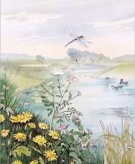
Midsummer Day – June 24th

I know a bank whereon the wild thyme blows
Where oxslips and the nodding violet grows
Quite over-canopied with luscious woodbine, With sweet musk-roses, and with eglantine:
There sleeps Titania some time of the night,
Lull’d in these flowers with dances and delight; And where the snake throws her enamell’d skin, Weed wide enough to wrap a fairy in.

(from A Midsummer Night’s Dream)
Midsummer has been celebrated for many a year as a magical time, it is a time of year often blessed with light, long, warm evenings. Our ancestors celebrated it in style and even today we have a sense of celebrating summer when we have fetes, garden parties, barbeques and cream teas in pretty outdoor settings. Shakespeare wrote about this Midsummer magic in his A Midsummer Night’s Dream – all about young love, love potions and fairies however, it is about more than that.
Why would an ass’s head appear in his play?
June 24th is celebrated, by the church, as the birthday of St John the Baptist – why did the church choose Midsummers Day as John’s Feast Day? The clue lies with Christmas.
The decision was made to celebrate Jesus birth on or near the Winter Solstice and at one time John’s birth was celebrated in January to emphasise his closeness to Jesus (also his cousin). But, it was reasoned that when the Angel Gabriel told Mary she would have a son and that her cousin, Elizabeth was ‘now 6 months pregnant’ – if we do our sums right, nine months before Christmas is March 25th and three months from March is June (for Elizabeth’s ‘due date’) In medieval England Johns birthday was sometimes called the ‘summer Christmas’ This is where the ass’s head comes in. An ass is always a major part of the Christmas Nativity play, when the feast day for John moved to Midsummer, a few stray ideas of tradition and folk law went with it, which is why in some old Midsummer festivals you will see a man dressed with an ass’s head and why Bottom the Weaver ends up wearing one in the Dream.
So why not have your own celebration for Midsummer Day (or St John) this year, summer pudding or scones in the garden and maybe a glass of Ginger Beer. Here is a recipe – I haven’t tried it yet so take no responsibility for the outcome!
First make a Ginger Beer plant:
In a clean large screw top jar put
1oz dried yeast
2 cups water
2 teaspoons sugar
2 teaspoons ground ginger
Feed it every day for seven days with 1 teaspoon of ground ginger and 1 teaspoon of sugar.
Keep in a COOL place – or it will explode.
DO NOT STIR IT.
After 1 week, strain it and add:
Juice of 2 lemons
2 pints of boiling water
1 pound of sugar

Make this up to 1 gallon with cold water. Stir, leave to stand for 3 hours.
Pour into bottles with screw tops. Leave in a COOL place for 2 weeks, then it is ready to drink.
With the residue in the muslin: split it, and give half to a friend.
Put each in a screw top jar with 2 cups of water, 2 teaspoons of ginger, 2 teaspoons of sugar – you do not need any new yeast. And begin the process again.
And you will soon have ‘lashings of ginger beer!’
Jane

bereavements
April 2020 brought the sad news of the deaths in quick succession of 2 long term residents of Middleton on the Wolds – Sybil MIlner and Lionel Eastwood. The sadness has been compounded by the impact of the Coronavirus which restricts numbers who are allowed to attend the “Service of Thanksgiving”.

Mrs Sybil Milner lived most of her 90 years in Middleton and sadly died in The Limes Care Home on 11th April. A beautiful, peaceful and meaningful service was conducted in our village cemetery by the Rev Jane Anderson and each one of those present was invited to place a red rose on top of the coffin as a symbol of love and remembrance.
Sybil was a remarkable lady. Kind, generous and caring with a “keen head for business” who worked actively and tirelessly all her working life. After a spell of catering at the Robin Hood, she bought a fish and chip shop in the village and continued to manage and cook on the premises for many years. Her passion for cooking and baking prevailed into her retirement and there was always some gastronomic delights to offer her many visitors.
She enjoyed being involved in all aspects of village life and the Tuesday Club fulfilled her many interests. During the latter years her health and mobility diminished but she continued to support and donate generously to St Andrews Church and to the many charitable events.
Watching TV was a bonus and her favourite quizzes tested her remarkable memory. She loved to recall the fun and pleasure of travelling abroad as well as the journeys taken in the UK. Son Adrian and granddaughter Kirsty were very dear to her and they, together with her many friends, will miss her greatly.

Lionel Eastwood lived his all of his life in Middleton and sadly died on 11th April aged 90 years. The “Service of Thanksgiving” took place at the Octon Crematorium on 1st May, conducted by Mrs Dorothy Prescott (reader) for the closest members of the family.
Lionel and his late wife Margaret celebrated their diamond wedding anniversary in April 2018, a fitting tribute to a couple who truly loved and respected each other – living generously with kindness and care. They were blessed with a son, 3 daughters, grandchildren and great-grandchildren whom they loved dearly and were so proud of their achievements.
During his active and fulfilling working life Lionel followed in his father’s footsteps, later inheriting the building business and has now left an impressive legacy of the many houses constructed by him and his team of employees.

He was an integral part of village life, taking on the responsibility of a valued Church Warden and for many years as a keen member of the Parish Council.
His involvement with the British Legion was commendable, acknowledging its importance and relevance. His love of playing bowls during his retirement gave him an extra focus and interest until his health deteriorated and he became so frail. Even so, when he was able to, he enjoyed attending the monthly lunches provided by the Robin Hood and always appreciated the “meals on wheels” which Mike from the pub kindly delivered.
Memories of all the good times we have shared in the past are treasured and the event last October celebrating Lionel’s 90th birthday encapsulated so much fun and fellowship.
Lionel was a real gentleman, kind and supportive and he will be sorely missed.

Mr Michael (Mike) Costello sadly passed away on 22nd April leaving a beloved wife Eileen, 2 sons, a daughter, 3 step children and grandchildren.
After meeting Eileen over 20 years ago he moved away from his home on Holderness Road to live in Middleton and in 2001 Mike and Eileen married. This was a perfect relationship, caring for one another and sharing so many mutual interests.
In his working life Mike was a well respected butcher and his knowledge and expertise in all areas of the business was impressive.
Mike was so very special, kind, gentle, loyal and generous – a wonderful host who made friends easily. He was a great family man and his family, especially the 9 grandchildren, were his greatest joy and he loved having them around.
He enjoyed being part of a village community and was always a stalwart supporter of social and fund-raising events.
His lovely garden and being close to nature was a constant solace and delight. Above all Mike demonstrated an enormous amount of courage, strength and determination during the times when he was so poorly – never complaining and always striving to enjoy life to the full. Eileen, his dear family and many friends will miss him greatly.

We must remember Mr John Mallory who sadly died in The Limes Care Home on 10th April and was interned in the cemetery at Middleton on 27th April.
John was born in Kilham in 1934 and lived in Middleton for some time with
Shirley whom he married in 1961 and his 2 sons, Neil, Derek and daughter Annette. In recent times he moved to Driffield with his second wife, Irene, to be nearer to the shops and other facilities.
John was a true gentleman and he will be sorely missed by his family and friends.

Our warmest thoughts and condolences are sent to all the families of Sybil, Lionel, Mike, John and Alan Walker at this sad time.

Betty Lowe
St Andrew’S church &
The wolds METHODIST CHURCH bainton
These churches are closed until further notice.
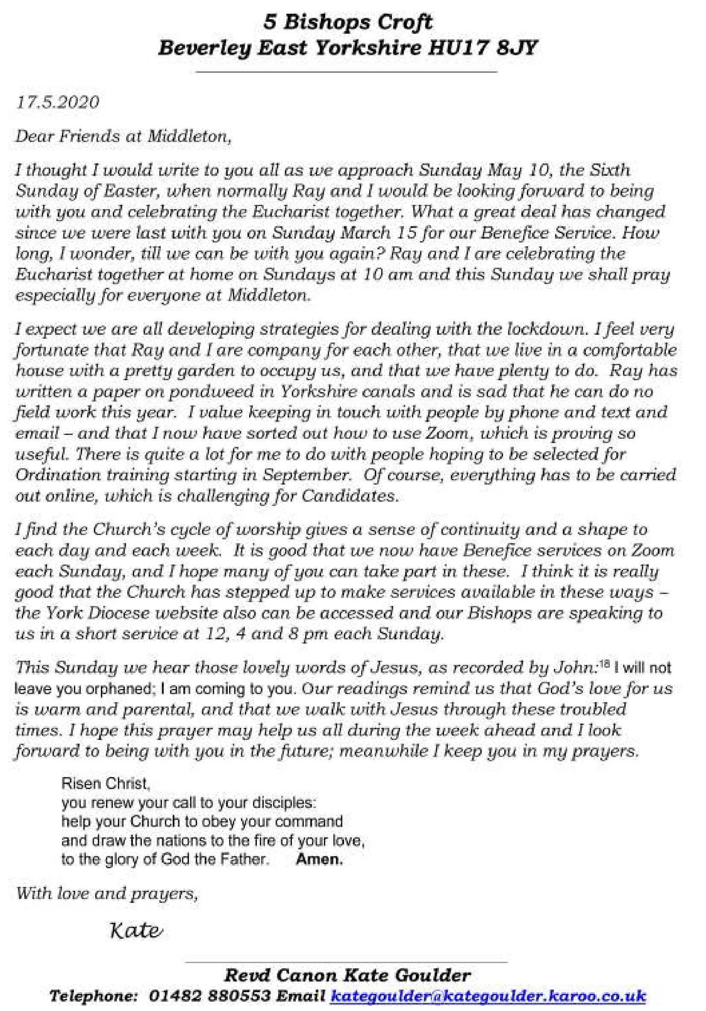

Middleton book group
May’s Virtual Meeting

Another Zoom meeting on our computers/tablets/mobile phones - at least some of us are able to chat and discuss the books. We all look forward to the time we can get together properly to enjoy a cup of tea and a piece of cake as well!

Lindsay chose this month’s books but wasn’t able to join us so these were her comments:

Enjoyed both books obviously but thought “The Lost Flowers of Alice” by Holly Ringland was a beautiful story, found it hard to believe it was a debut novel. Harrowing at times, but life is! Found it so touching when despite what she was enduring Alice's mother instilled in her a love of flowers which continued when she went to live with her Grandmother and the women working at the nursery who all had a story to tell. The description of the various areas of Australia was breathtaking.

“Nine Perfect Strangers” by Liane Moriaty was a novel concept whereby nine very different people arrive at a wellness centre hoping to achieve a variety of outcomes. All characters are plausible and begs the question regarding the relentless quest for self improvement.

From the meeting: Two had read The Lost Flowers of Alice and both found it rather depressing (it is about abuse by a father). Five had read or were reading Nine Perfect Strangers and all enjoyed it. We thought the characters were interesting and well portrayed and liked the way their opinions of each other changed as things progressed. Good to be told what everyone went on to do at the end.

Next books for discussion:
June “Mr Starlight” by Laurie Graham
“Left Neglected” by Lisa Genova

To find out more about the Book Group please contact Lyn on 219500 or lyndennis456@gmail.com

Parish council
Our May meeting of the Parish Council was our first ever remote parish council; with members connecting through Skype. This seemed strange at the time but until we beat this Coronavirus – Covid 19 we will have to continue in this manner. Please note that if any parishioner’s wish to join us at our next virtual meeting or any future ones; our parish clerk or any of the parish councillors can advise how this can be arranged.
Due to the difficult times we are going through we were advised by the authorities that we did not have to elect a new chair and vice chair of the parish council; and we voted to appoint the delegation of sub committees and appointment of officers as detailed below.

A draft copy of our minutes can be viewed on our web site. http:// www.middletononthewolds.co.uk/minutes.aspx

I am sure we all want the lockdown to be eased further and for the country and the world to get back to normality; however I am sure that many people will have noticed the village coming together more; with many of us distance meeting and talking to people from the village who we previously did not know. How good it is to see people walking and exercising and appreciating the walks around the village.
People are helping their neighbours with shopping and checking they are in good health.
We have local businesses both selling and delivering groceries, fruit and meat to the village; our village pub is offering take away meals on various days; and of course our post office offers a great facility and support to the village.
There are also many people out clapping, banging pans etc. on a Thursday night; showing their support and appreciation to our NHS.
The afternoon tea VE Celebrations in the village, particularly on Greenfield Road was wonderful to see. It again showed how people have come together; creating their own small parties with the friends and neighbours.
As I commented in the April edition Middleton is a great village and I certainly know more of the people from the village; so I hope others also do.
Finally there is currently a vacancy on our Parish Council so if anyone is interested please initially contact our Parish Clerk.
John Eastwood

MIDDLETON ON THE WOLDS COMMUNITY PLAN 2020
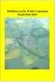
The village Community Plan has been completed and it was hoped to have been launched at a public meeting in May but due to the Coronavirus distancing restrictions this was not possible. Whilst the Parish Council hope to hold an open day event later in the year copies of the plan will be available and delivered to all households this month. It will also be available on line via the Parish Councils website www.middletononthewolds.co.uk.
Any comments or initial feedback can be made by using the contact form on the Parish Councils website or by e mailing Councillors Nick Jones or Alex Lowsley via nj@motwparishcouncil.co.uk.

LITTERING
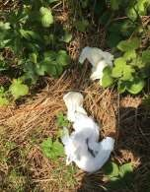
As the Lockdown continues it’s been great to see people out on their daily exercise walk, many with dogs walking around the village and surrounding lanes. 10,000 steps are a daily walking target for many and with the recent good weather has been a pleasant target to achieve for some, including yours truly! The Village Wombles have also noted a general decline in the amount of litter which is brilliant! However there still appears to be a small hardcore of folk who treat our village as a dumping ground and a large amount of litter including surgical gloves and a blue apron were recently found by the public footpath along Beverley Road. It amazes me that someone can be so thoughtless, can put others at potential risk and this type of rubbish suggests that it was left by someone connected to the Health/Care Industry which makes it even more unbelievable! Regular checks and the removal of rubbish will continue and safely removed but please continue to do your bit and use the village bins provided. Thank you
Nick Jones
Parish Councillor
Middleton on the Wolds Parish Council
Councillors and areas of responsibilities
Name | Address | Committees/Responsibilities
John Eastwood | 49 Front Street | Planning
(Chairman) | 01377 219000 | Reading Rooms Committee
Mike Kelly | Parkside Lodge | Recreation Club, Newsletter
(Vice Chair) | Church Hill | Reading Rooms Committee (Chair)
 | 01377 70169 | Pig Liaison Group
Kath Bentley | 19 Greenfield Road | Reading Rooms Committee/ Bookings
 | 01377 217456 | Cemetery
John Fisher | 14 Front Street | Play areas
 | 01377 217587 | Reading Rooms Committee
June Pratt | 12 Station Road | School Liaision Officer
 | 01377 217453 | Village Hall Liaison officer
 |  | Quarry Liaison Officer
Tina Walker | 2 The Paddocks | Highways, Pig Liaison Group
 | 01377 217242 | Quarry Liaison Officer, Newsletter
Alison Wilson-
Dodd | 12 Front Street | Reading Rooms Committee
 | 07875 216232 | Allotments Co-ordinator
Nick Jones | Anvil Cottage | Highways
 | 8 Station Road | Community Planning
 | 01377 821077 | Safeguarding Officer
Dave Carlin | 5 South Drive | Play areas
 | 01377 219417 | Community Planning
Alex Lowlsey | 13 South Street | Play Areas
 | 07823 789828 | Community Planning
Sandra Morrison The Grange, Main Street Parish Clerk
01262 470496 Thwing YO25 3DY Finance Officer, Burial Clerk pc@middletononthewolds.co.uk

Local Birds & wildlife
The weather has varied a lot since the last Messenger; we’ve had scorching hot sun (unfortunately particularly on the day of the VE Day celebrations – it ended up too hot to stay in our front garden and be sociable) and now slightly frosty nights and chilly days. There are plenty of nests full of starling fledglings round our way judging by the cacophony of wheezy enthusiasm each time an adult arrives on our roofs, I just hope that there are still enough insects to feed them after the cold nights.
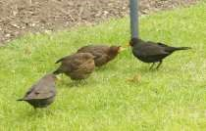
The blackbirds must have nested earlier as we now have harassed adults pursued by their large noisy infants in the garden. A few days ago I was sitting still by our little pond, and I noticed one of the young blackbirds trying to pluck up courage to get a drink. It kept approaching then hopping away again. One of our more confident robins turned up, and hopped towards the pond. It paused to
LD

turn over a few bits of gravel and found a few juicy titbits under them, then went and had a drink from the pond before flying off. The young blackbird watched all this, then to my surprise went to exactly the same patch of stones as the robin and had a little poke around, then went to the exact place where the robin had drunk to refresh itself before flying off. I know birds copy their parents to learn how to feed, but I didn’t know they learned from other species as well!
The food in our feeders is now going down very quickly as not only has the pheasant learned how to balance precariously on a food tray to reach the largest feeder, but we have also had visits from a rook and two jackdaws, who don’t stay long but seem to rather take over the garden for a few minutes – you don’t realise how big they are until you are close to them!
We now have a regular hedgehog caught on our night camera; it seems to spend a surprising amount of time sniffing around on the lawn as well as investigating the dug up earth (I won’t dignify that by the term “flowerbeds” because one day we will be getting visitors again, and they might remember me referring to them as such). To begin with we didn’t put the camera in a very good place and all we saw was a large spiny bottom disappearing into the gloom.
I have seen lots of swifts circling overhead and calling before it cooled down this week, and Hazel phoned to say she had heard a cuckoo calling! I don’t think it has been heard since, so I expect she was right when she said it might just have been passing through. It is many years since I have heard a cuckoo here, so it has come as a surprise when we have been on holiday in the West of Scotland and found them thriving there.
You know when you see something flashing by out of the corner of your eye and are not sure what you have seen? Looking at the garden out of the window the other day – was it a bird? Was it a very small superhero? No, it was a vole, rushing between two clumps of vegetation. I watched it go to and fro several times, then wandered up the garden to have a closer look, and was surprised to find a tiny shrew sitting under a large leaf and nibbling on a tasty snack! Voles and shrews come in various sizes; these were a largish vole and a very small shrew. They both have short tails, but voles have blunt faces, while shrews have pointy noses that whiffle around.
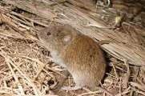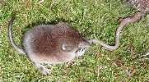

It just goes to show that you never know what will turn up when you least expect it! Speaking of which, white tailed eagles (sea eagles) have been introduced on the Isle of Wight and this year have been reported roaming from there up as far as Oxford, Northampton and North Yorkshire so if you look up and see a huge bird that could reasonably be described as “a flying barn door” …… I will be extremely jealous! (NB Ian took the eagle pics, but
unfortunately the watery one is not our pond, but on Mull).

Please send me any interesting sightings/anecdotes/pictures at lavenderbarbara97@gmail.com or phone/text on 0777 192 7868
Keep safe, Barbara

LOCAL HISTORY
RAIL TRAVEL COMES TO MIDDLETON

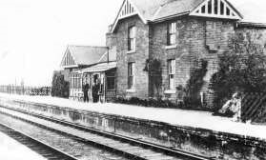
The railway was a late arrival in Middleton but when it appeared, it joined with the already established telegraph to provide a taste of the forthcoming age of speedy communications which were to make such changes in the life of the country as well as giving the village easier access to the outside world rather than total reliance on the carrier’s cart.

It was felt that the existing line from Selby to Market Weighton could be extended to Driffield thus giving the West Riding easier access to the coast. Much of the existing railway network of the East Riding was the product of the frenzied influence of George Hudson the “Railway King” whose reign was terminated by his cavalier attitude to money matters, who briefly owned the Londesborough Estate and served a prison sentence before his death in 1871.

Construction of the link, a double track line, commenced in October 1888, the work being carried out by John Fraser and Sons of Leeds at a cost of £230,000 and was taken over on opening in April 1890 by the North Eastern Railway Company. There were four stations on this new section: Enthorpe, Middleton-on-the-Wolds, Bainton and Southburn and although it involved cuttings and extensive embankments the engineering works had not been onerous with no tunnelling required. During the excavations between Enthorpe and Middleton bones and rusted iron were found in a deep cutting which were considered to be part of an Iron Age chariot burial. It is believed that only one of the items found, a linch pin, was preserved.

It is said that a family of construction workers resided in part of the property now known as “Quackers” which is situated near the pond. Another worker was David Bradley Soanes, born in North Dalton in 1859 who served as a carrier in his father’s business. In 1891 he bought a grocery and drapery shop and later opened a sand pit and sold sand in Front Street. The uncle of Tom Soanes, he died in September 1960 at the age of 101.

At the time it was thought that this new section of railway which completed the line would boost the prosperity of Driffield and Bridlington, the latter, already having the holiday trade, being poised for expansion as a port in connection with the fishing interest and as a potential trade link with Scandinavia and Hamburg. Locally it meant that a person in the village could, with sufficient funds, access the national rail network and in her book “ My Story” Winnie Cook recalls walking across two grass fields from Lund and along the railway track to take the train to Market Weighton, then to York and onwards to Kings Cross when she left to begin her wartime naval career.

Percy Linford (1914-1997) who met some of the original construction workers recalled that the station had a warehouse and a weighbridge whilst cattle were housed nearby awaiting transport. Cereals were sent to the flour mills and wool was also conveyed. Coal was brought from South Yorkshire and dropped off at local stations to order and then delivered around the village by cart. Percy’s daughter Pam recalls a subsequent coalman Wilf Soanes allowing children to ride in the back of his lorry which she did until her joyrides were stopped by her mother. The station staff consisted of the station master, the first being George Julian of Lund, a clerk, porter/ signalman and porter plus three platelayers who worked on the line.
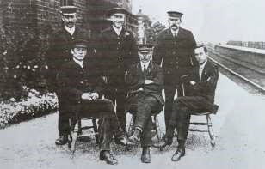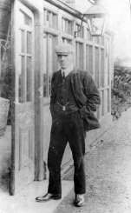

As the 20th century progressed however the competition from road transport was too strong and the line closed to goods traffic in 1954 and passenger services in 1965. In an elegiac article in the Driffield Times Tim Healey contrasts the high hopes and aspiration for the line on its inception and its sad demise. It reads, “In the intervening years people of the West Riding have travelled this route in hundreds and thousands as an escape to the sun and undeniably Bridlington has felt the wind of good fortune. Now all is silent, no longer will the rabbits go scurrying across the fields at the sound of approaching trains, the intermediate stations, already out of use, can no longer serve as a reminder that a new age has taken full toll.”

The imposing brick viaduct in Warrendale lingered on after the line closure but was eventually demolished some years ago whilst part of the track, elevated in places and once joined by a bridge across Station Road, is used for recreational purposes and is particularly popular with dog walkers.

But let us finish with the words of Pam Linford. “I remember many happy trips to the seaside by train – very easy - no parking problems! The trains had no corridors, just a series of compartments with overhead net luggage racks and strange windows with leather straps that had to be fixed to a button on the door to hold the widow open. If the window was open there was a danger of the engine smoke getting in – sometimes when we got off the train there was quite a lot of soot on our clothes” That memory is enough to set the blood racing in the veins of any steam buff!

Geoff Wisher

Can anyone put names to any of the railway staff in the photos? Please let us know on 219500 or middletonflyer@yahoo.com

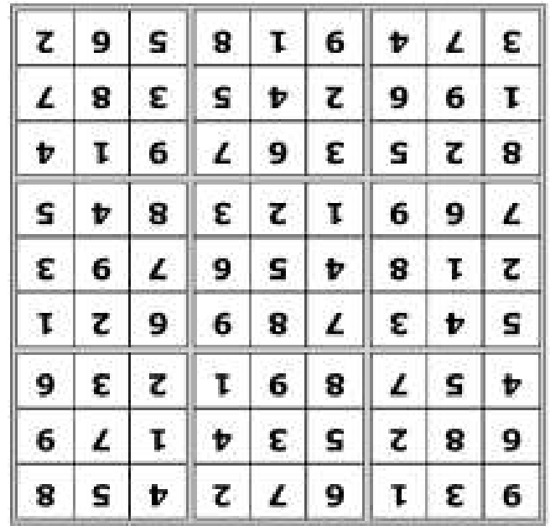
Quiz answers

Where in Middleton:

Clothes collection bin
-

Robin Hood car park

Village Farm, off
South Street

Old telephone kiosk

Dingbats:

Chorus Line

Fiddler on the Roof

Half a Sixpence

Camelot

A Little Night Music

Lion King

1

The Lake District.

2

The Cutty Sark

3

Little Jimmy Osmond, age 9
years 8 months, with
“
Long
Haired Lover from Liverpool
”

4

Inverness

5

29

6

There is no dirt in a hole.

7

Sacramento

8

st January,
1
1999.

9

Brown

10

Jules Verne

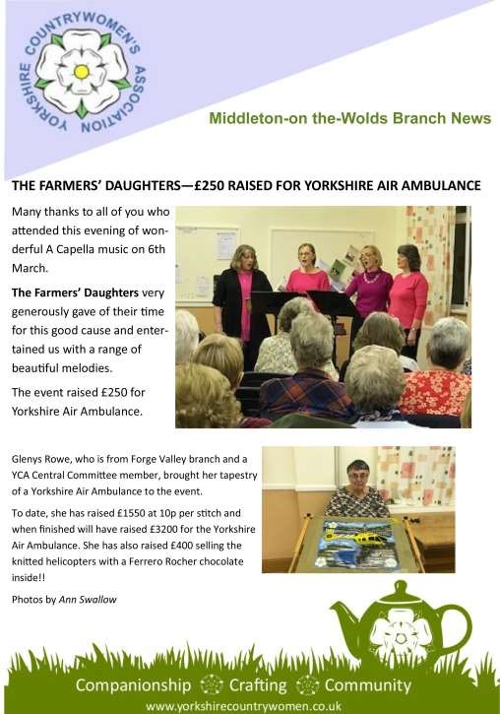

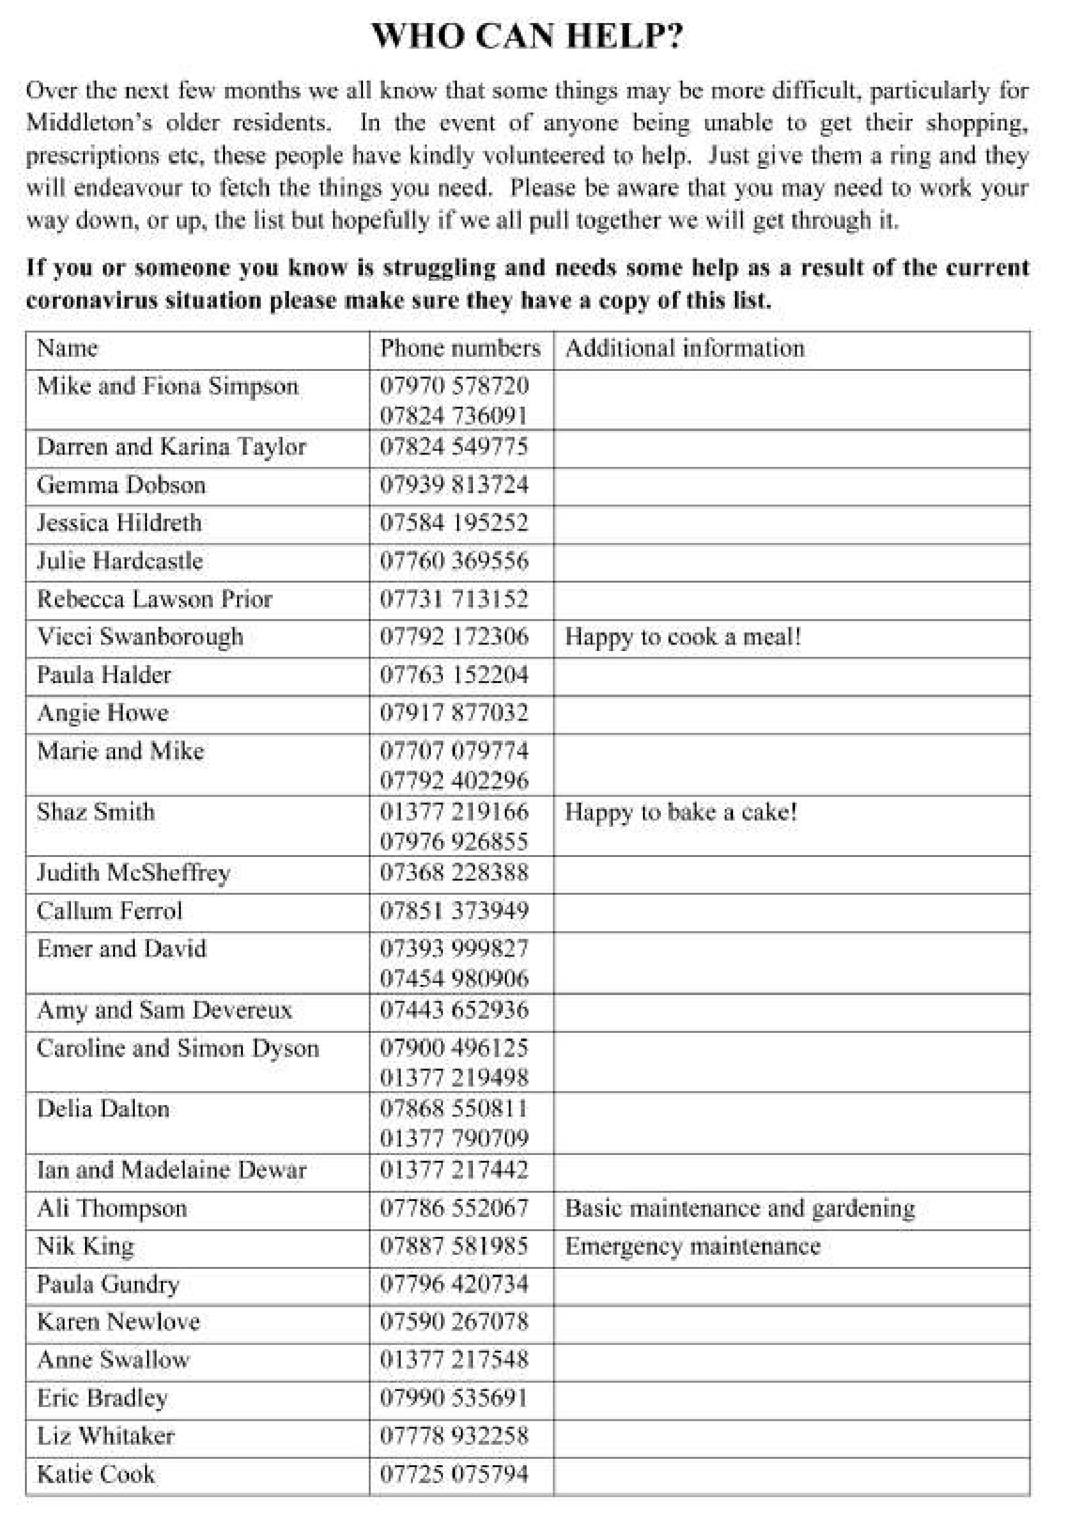

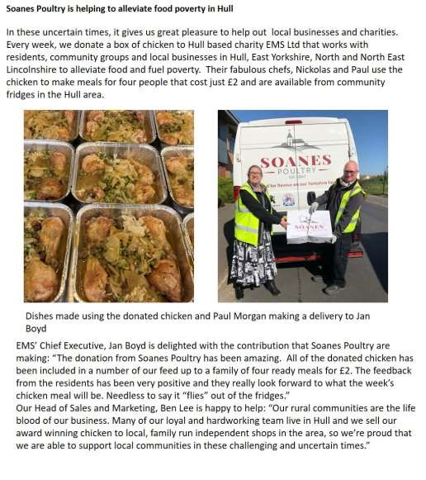
Advertising Feature

Advertisement
Advertising Feature

LOCAL CONTACTS Bell Ringing Chris Atkin |  | 217285
Book Group/Middleton Movers | Lyn Dennis | 219500
Bowls Club | Rob Bradley | 217435
Country Women’s Association | Christine Johnson | 217374
First Responders | Chris Brent | 219469
Line Dancing | Pat Pottage | 217516
Methodist Chapel | Miss P Hodgson | 217426
Middleton Messenger | Mike Kelly | 07713 620912
 | Lyn Dennis | 219500
 | Tina Walker | 217242
Middleton Womblers | Andrew Naylor | 219072
Parish Clerk | Sandra Morrison | 01262 470496
Reading Rooms | Kath Bentley | 217456
Recreation Club | Dave Newlove | 07901 833784
St Andrew’s Church | Rev Jane Anderson | 219471
St Andrew’s Church Warden | Roger Lowe | 217656
Table Tennis | Louise Newlove | 217801
Village Hall Lyn Dennis |  | 219500

